1. How to Delete the relationship between tables ?

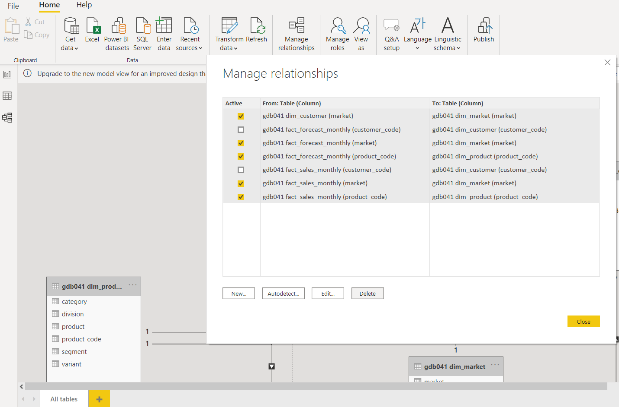

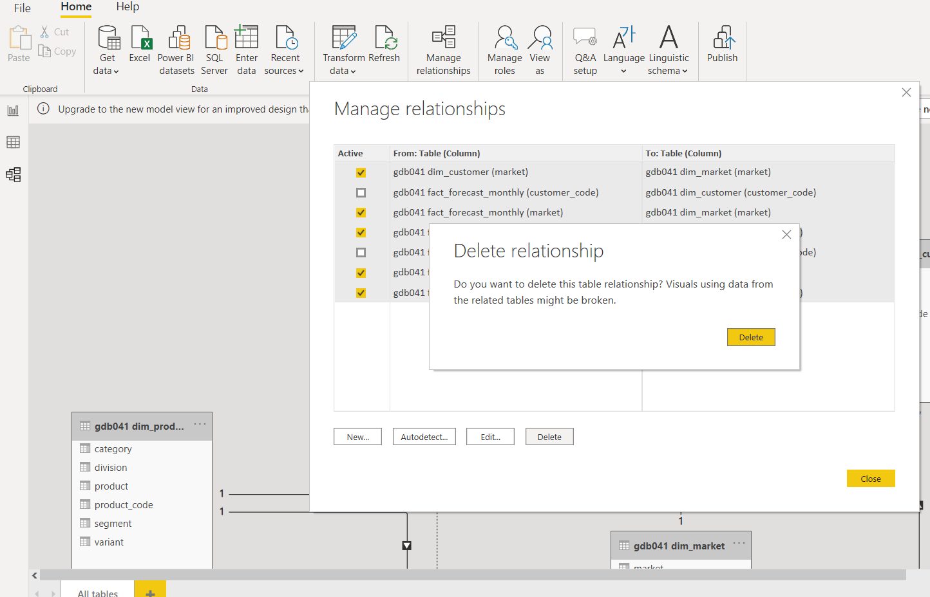

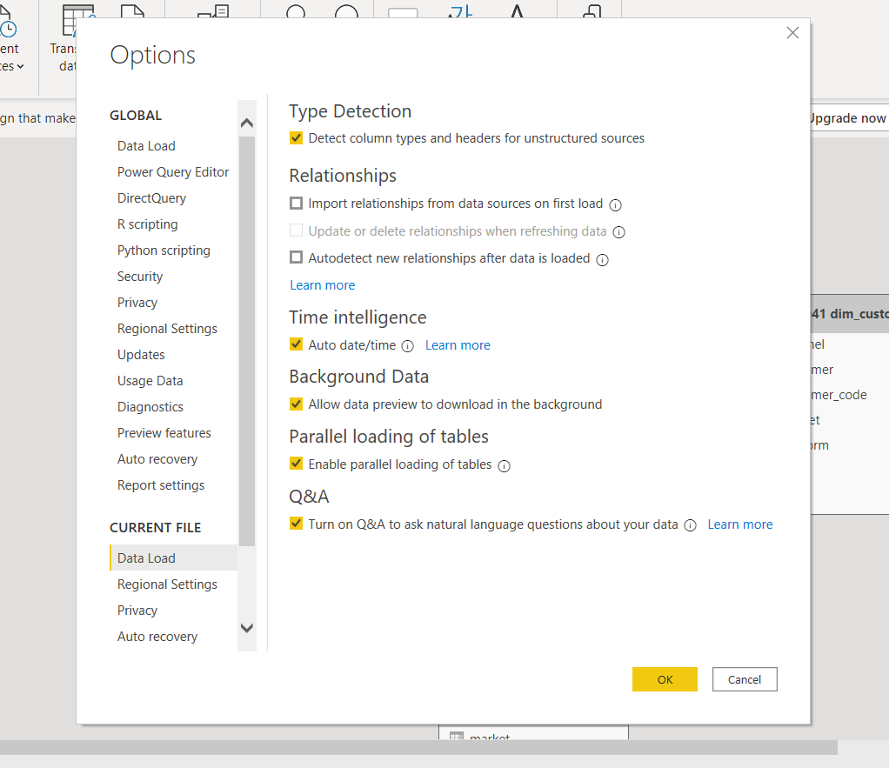

1. How to connect Power BI with Mysql

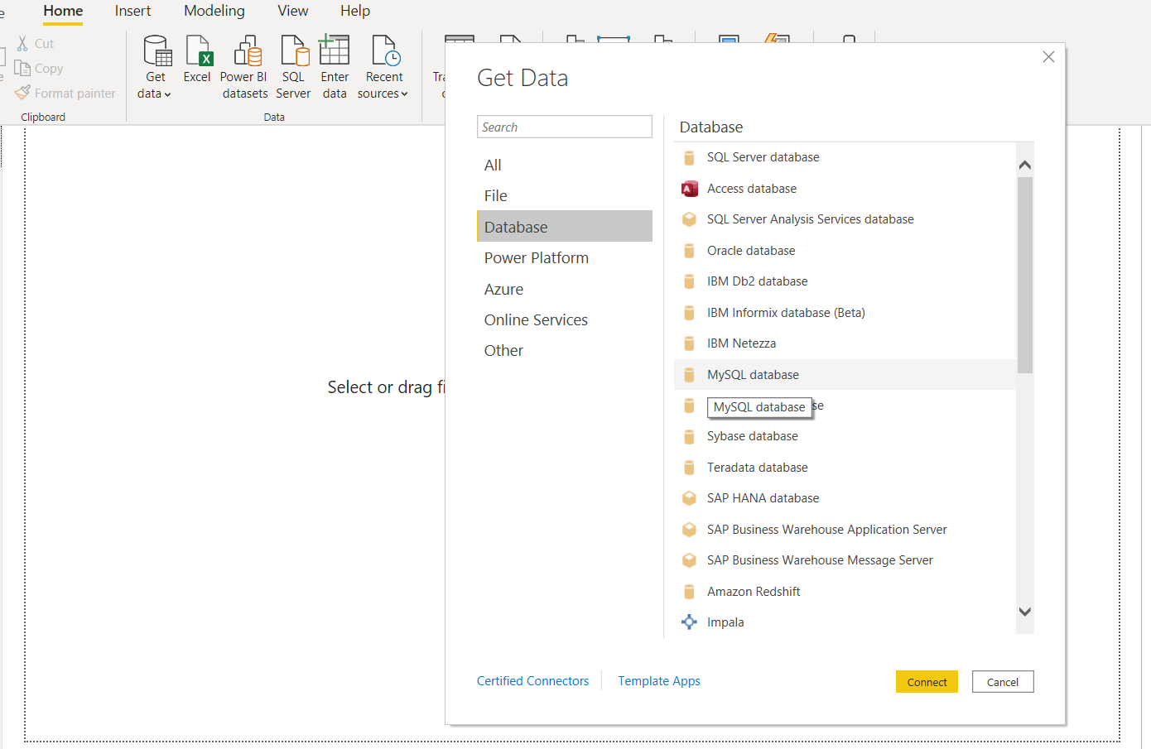

1. Column Distribution & Column Profile

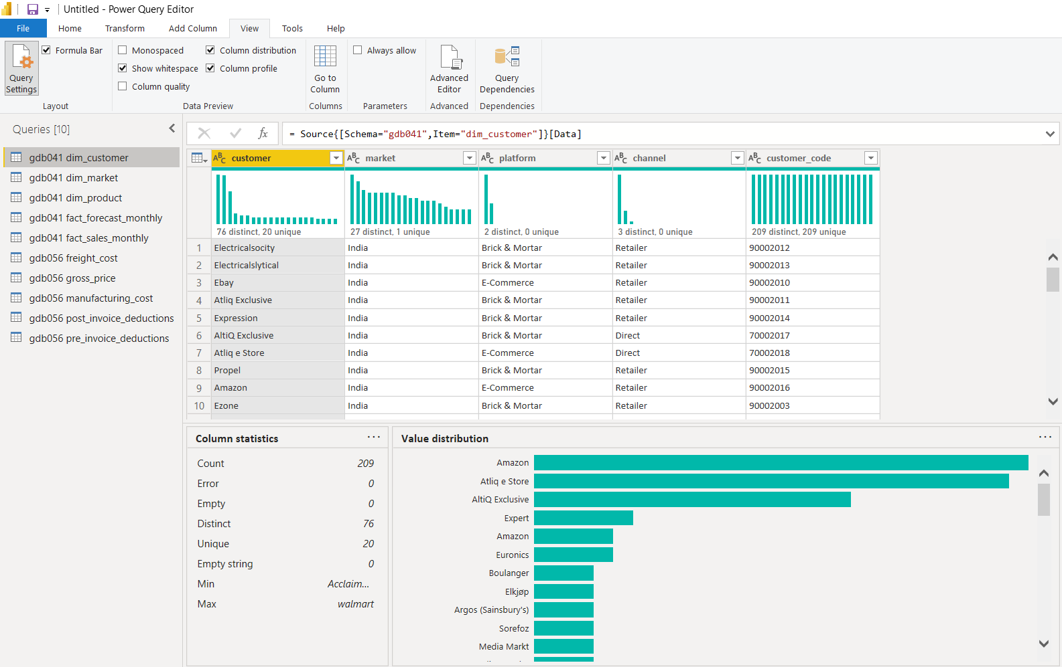

1. How to create date table

Blank Query

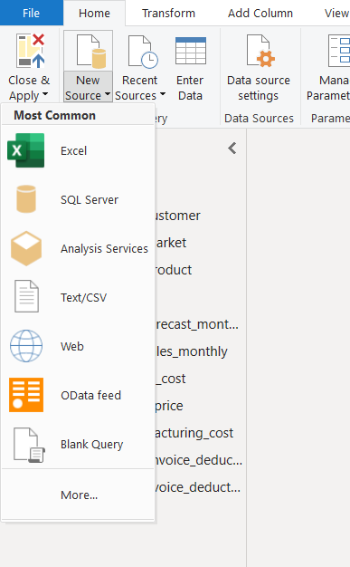

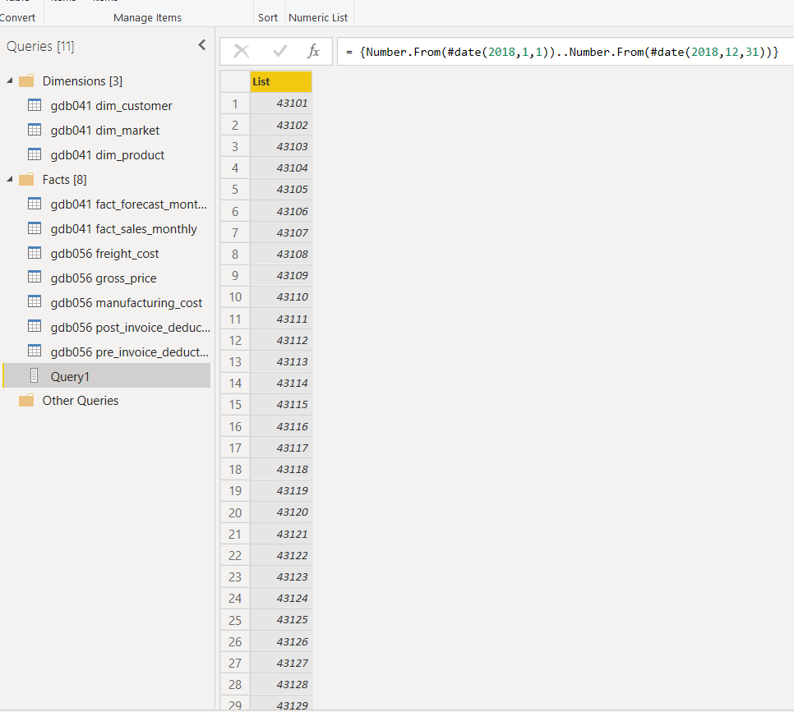

To table

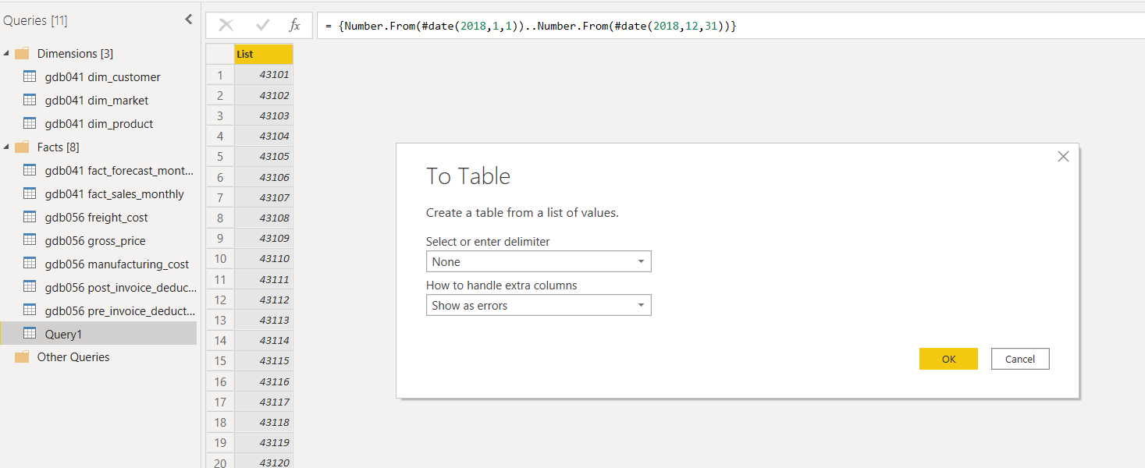

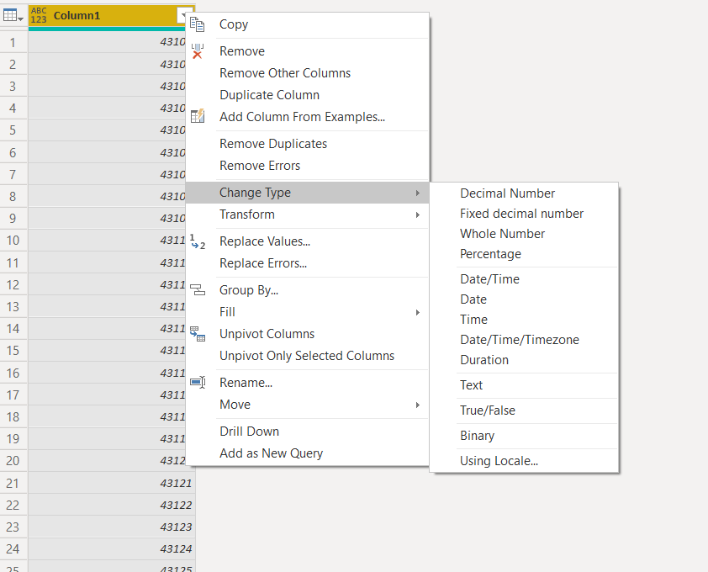

1. Fiscal Year calculation

* Create date column
* Find the month out of it
* Add some months based on the fiscal year
* Here, September is the start month, so adding sep, oct, nov, dec to 2018 (like January)

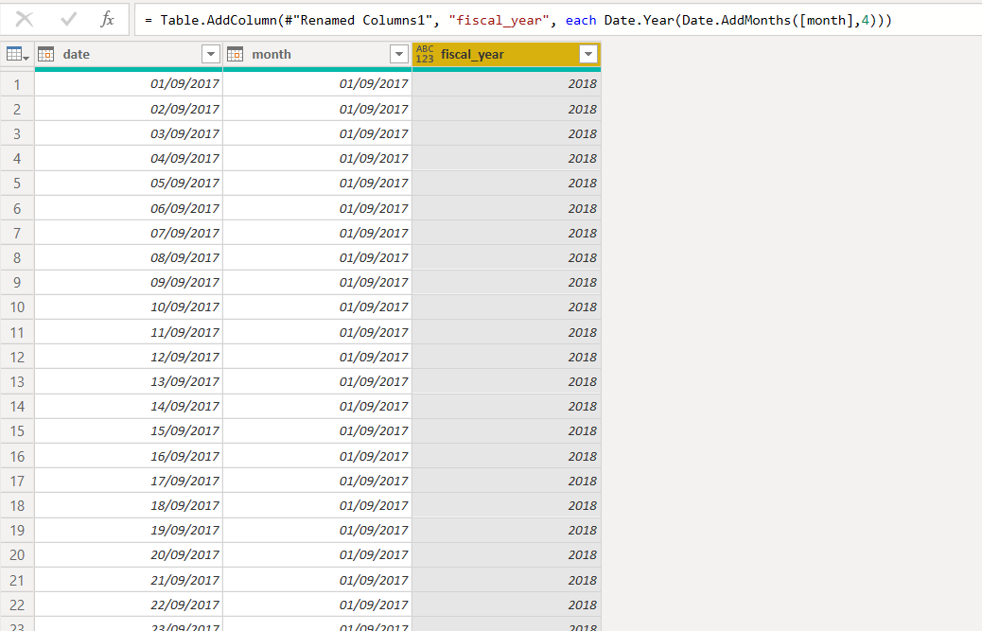

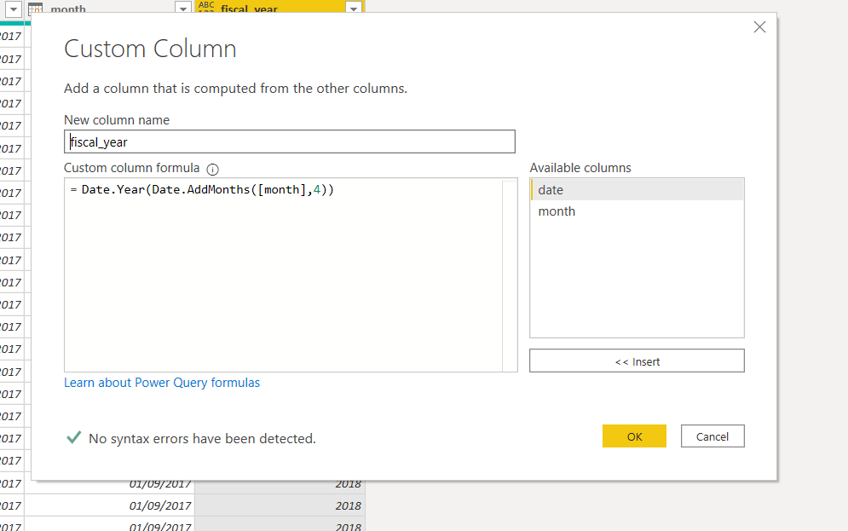

1. Combining Actuals and Forecast

* Last Sales month

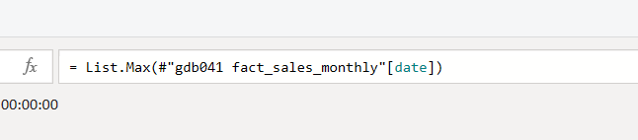

* actuals till last sales month (sales table)
* create the new table - forecast for the remaining months (Forecast table)

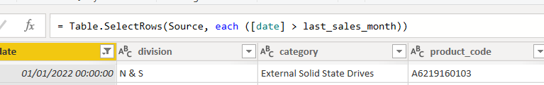

* Rename Forecast quantity as Qty in Forecast table
* Rename Sold quantity as Qty in Sales table
* Combine these 2 tables

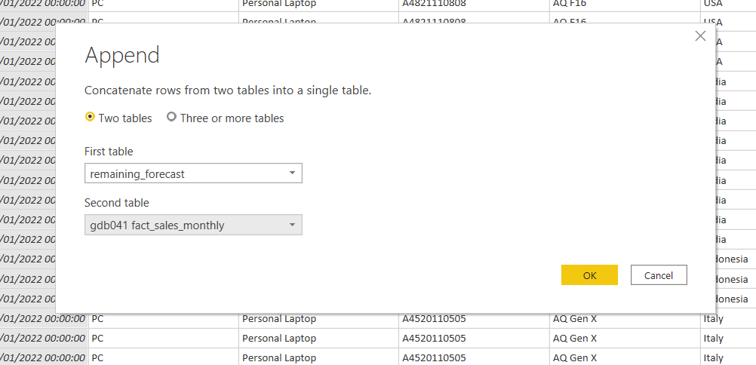

1. How to choose columns

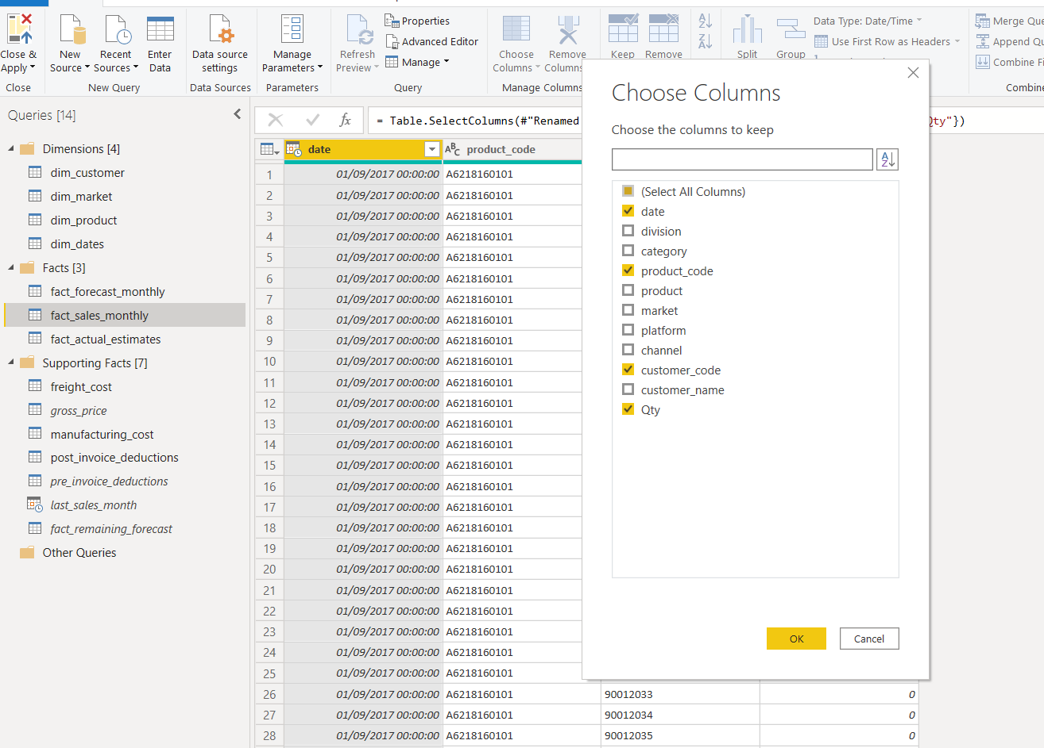

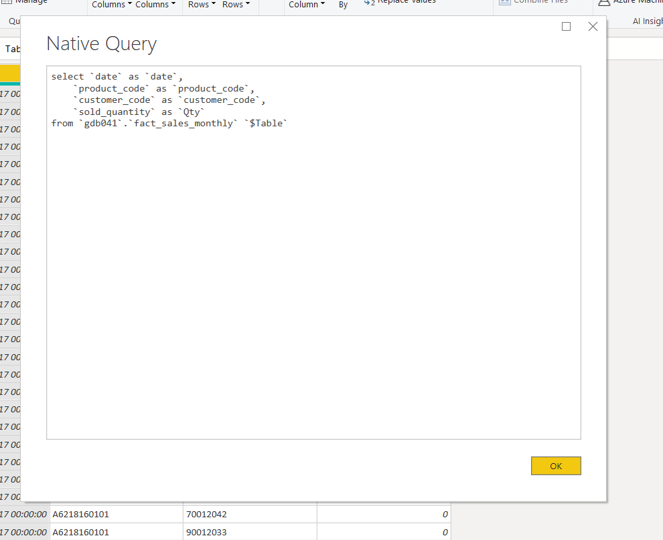

This can improve the performance.

It queries only the data of the selected column from the source.

Query folding is the ability in the power query to generate a single query statement to retrieve and transform the source data.